Methods for numerical solution of first order ordinary differential equations

The goal is to develop a program for a numerical method for integrating ordinary differential equations.

Task
Find a solution to a first order ordinary differential equation
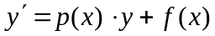
on the segment 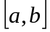 provided that 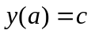.
Option number according to the subgroup list.
1. Find an approximate solution using Euler’s method.
2. Find an approximate solution using the Runge-Kutta method.
3. Find the exact solution of the equation.
4. Compare the solutions obtained.
5. Submit the report in printed form
6. Task option according to the subgroup list

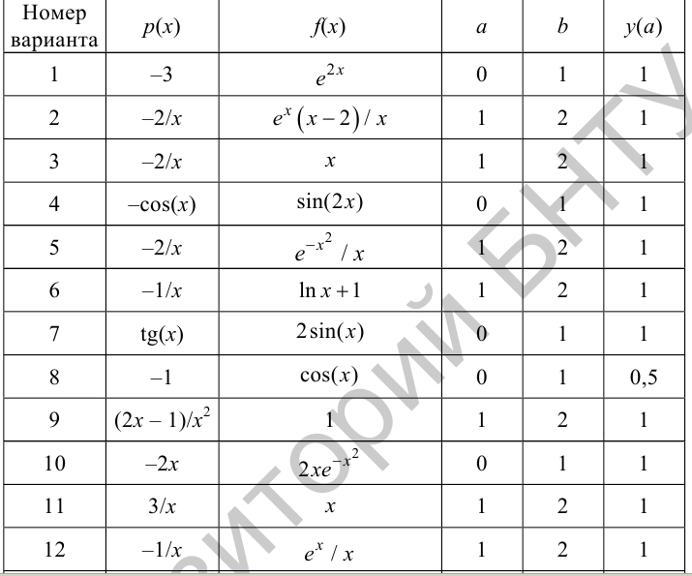
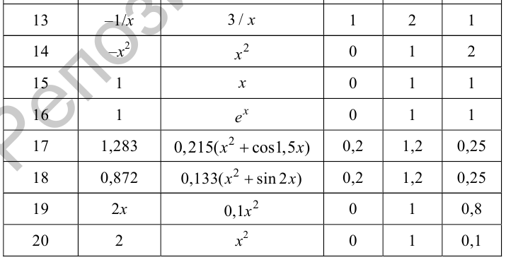

Literature

https://rep.bntu.by/bitstream/handle/data/18609/Основы%20метода%20конечных%20элементов%20в%20мехатронике.pdf?sequence=1

Added by A.A. Kornienko

